CHAPTER 1
- INTRODUCTION
Cloud Computing is the emerging technology where the services are provided over the Internet. This has become a preferred option for many business contexts. Rather than owning the resources, they are used on a rented basis. This avoids the cloud user the head ache of managing the resources which has to be owned by them instead. For providing the service by the cloud service provider and using the services by the cloud user, an initial agreement called the Service Level Agreement (SLA) has to be made between the cloud users and the cloud service provider. While resource allocation is made to the cloud user, SLA violation should be avoided as much as possible or SLA violation should be minimal without compromising Quality of Service (QoS) parameters like performance, availability, response time, security, reliability, throughput etc. In order to efficiently utilize resources, various resource allocation techniques are to be used. For allocating the resources, virtualization technique has to be used. Since the actual physical resources available are less than the resource demand, virtual resources are to be created, mapped onto the physical resources, and these virtual resources are to be allocated to the requesting cloud user. After utilization of the virtual resources, they have to be destroyed by the cloud service provider. All these have to be made without violating SLA by meeting QoS. With the limited amount of physical resources available, resource allocation becomes a challenging task for the cloud service provider. Since cloud computing is a multi-tenancy model, multiple users‟ requests for the cloud resources. So cloud service provider has to decide on how many virtual resources are to be created based on the cloud users‟ requests. Also which virtual machine (VM) has to be mapped onto which physical machine (PM) has to be taken care. That is, VM-PM mapping techniques have to be considered. At what instance VM migration has to be done is also based on identifying heavily loaded node and lightly loaded node. So the ultimate goal of the cloud service provider is to maximize profit and maximize resource utilization and the goal of cloud user is to minimize payment by renting the resources. There are various parameters to be considered while allocating resources. While allocating resources to the cloud user, underutilization (wastage) of resources due to over provisioning and overutilization (due to under provisioning) should be avoided. Allocation of resources should consider various parameters like Quality of Service parameters like response time, performance, availability, reliability, security, throughput etc.
Performance: For some application demands, performance is one of the important criteria. The system should perform well to provide service to the cloud user.
Response Time: For interactive applications, response time is an important factor. The system must respond well for these kinds of applications.
Reliability: The system used should be reliable so that the cloud user has no head ache of changing the system.
Availability: Whenever cloud resources are requested the cloud service provider must be able to allocate within short span.
Security: For critical applications like online transaction applications, system used has to be secure. Otherwise it is not safe to use such a kind of system.
Throughput: No. of applications run per unit time should be more. There are two major types of resource allocation techniques.
Static Allocation: In this case, the cloud user has to make prior request for the resources. By doing so user knows what resources are required and how many instances of the resources are needed ahead of using the system. But the drawback in this case is it leads to underutilization or overutilization of resources depending on the time the application is run.
Dynamic Allocation: Cloud resources are requested by the cloud user on the fly or as and when the application needs. Here underutilization and overutilization of resources is avoided as much as possible. But the requested resources might not be available when requested on the fly. The service provider has to make allocation from other participating cloud data center.
Recent advances in distributed computing have brought a paradigm shift in the computing world. The practices of dedicated access to computers owned by individuals or organizations have been replaced by on-demand accesses to resources shared among many individuals and different organizations. Cloud computing has largely contributed to this transition by enabling ubiquitous, convenient, on demand network access to a shared pool of conﬁgurable computing resources (e.g., networks, servers, storage, applications, and services) that can be rapidly provisioned and released with minimal management effort or service provider interaction
Present practice in the cloud computing arena is that the cloud service users (CSUs) request for resources and cloud service providers (CSPs) allot the virtualized resources to the CSUs according to their requirements. However, while requesting the resources, CSUs face a major challenge due to various pricing schemes offered by the CSPs. Resources are available on reservation basis, as well as on demand basis. Reservation is to be done for a ﬁxed contract period with a ﬁxed price. However, reservation for a longer period or for larger amount of resources than that required to meet the demand for resources of an application, may lead to over-provisioning and higher cost for the CSUs. On the other hand, on-demand prices are generally higher than the reserved one and therefore if the resources are allotted only on-demand basis, cost to be paid by the CSUs will again be high. Therefore, some optimization strategies are required to reduce the resource usage charges from the users’ point of view.
Cloud computing is one of the latest models used for sharing pool of resources like CPU, memory, network bandwidth, hard drive etc. over the Internet. These resources are requested by the cloud user and are used on a rented basis just like electricity, water, LPG etc. When requests are made by the cloud user, allocation has to be done by the cloud service provider. With the limited amount of resources available, resource allocation becomes a challenging task for the cloud service provider as the resources are to be virtualized and allocated. These resources can be allocated dynamically or statically based on the type of request made by the cloud user and also depending on the application. In this paper, survey on both Static and Dynamic Allocation techniques are made. Also, comparison of both static and dynamic resource allocation techniques is made.

CHAPTER 2
- LITERATURE SURVEY
Cloud Computing has become an extremely attractive topic of research and application these days. NIST has defined Cloud Computing as “a model for enabling convenient, on-demand network access to a shared pool of configurable Computing resources” Cloud security and storage have grasped lots of attention in this field In term s of storage, it acts as the lower layer of cloud infrastructure that supports the other layers’ functionality. Also, since it is important to make data storage redundant in different locations as contingency planning to ensure availability of cloud services, it would incur huge operating costs for the providers
In order to achieve this aim, a number of objectives have been outlined:
- Understand the importance of cloud computing, architecture of clouds, types of clouds, models of clouds, and virtualization.
- Understand some issues associated with Cloud Computing in terms of data centre management.
- Understand Cloud simulation, in particular CloudSim toolkit in terms of its usability, capability and limitations to offer a feasible evaluation of the eco-efficiency techniques used in data centers.
Most of the cloud applications, such as online office and social networking, rely on tight interaction with databases. Data queries can be fulfilled either locally or from a remote location. To ensure data availability and reduce access delays data replication can be used. Database replication decisions can be based on the data usage patterns and analysis of data popularity. The popularity is measured as a number of access events in a given period of time. Furthermore, the popularity is not constant over time. Typically, a newly created data has the highest demand.
Then, the access rate decays over time. For example, a newly posted YouTube video attracts most of the visitors. However, as the time passes it starts to lose popularity and the audience.
- Several studies of HTTP requests and social networks suggest using a power law distribution which has a long-tailed gradual decay.
- The update rate of any data is more as the replication is done with some expressions.
- Energy consumption of computing servers is more.
- Storage requirements of data replication are high in the process.

There are two main approaches for making data center consume less energy: shutting the components down or scaling down their performance. Both approaches are applicable to computing servers and network switches. The performance of cloud computing applications, such as gaming, voice and video conferencing, online office, storage, backup, social networking, depends largely on the availability and efficiency of high-performance communication resources. For better reliability and high performance low latency service provisioning, data resources can be brought closer (replicated) to the physical infrastructure, where the cloud applications are running. A large number of replication strategies for data centers have been proposed in the literature. These strategies optimize system
bandwidth and data availability between geographically distributed data centers. However, none of them focuses on energy efficiency and replication techniques inside data centers. To address this gap, we propose a data replication technique or cloud computing data centers which optimizes energy consumption, network bandwidth and communication delay both between geographically distributed data centers as well as inside each datacenter. Specifically, our contributions can be summarized as follows.
- Modeling of energy consumption characteristics of data center IT infrastructures.
- Development of a data replication approach for joint optimization of energy consumption and bandwidth capacity of data centers.
- Optimization of communication delay to provide quality of user experience for cloud applications.
- Analysis of the tradeoff between performance, serviceability, reliability and energy consumption.

Cloud infrastructure is equipped with large and power consuming data centres that bring challenges to managing the power consumption eco-efficiently. As has been stated by Scheihing, data centres consume about 10 to 100 times more energy per square foot than typical office buildings. They can even consume the same amount of electricity that is used by a city. Also, high energy consumption in a data centre can lead to extreme heat dissipation which would raise the cooling costs and make the servers vulnerable to risks and failures. All these issues would also inflate the operational costs in order to maintain and keep the data centre functioning. Additionally, governmental policies across the world push data centre providers to reduce energy waste and become greener with regard to the environment. Thus, using certain eco-efficient mechanisms, like DVFS and VM allocation, to reduce the energy consumption can help to enhance the sustainability and profitability of the data centres and make them greener.
Most of these previous works for optimizing cost use some form of integer programming model which is NP in nature. They have solved the problem using some techniques like benders decomposition and sample-average approximation as have been used in [16]. To the best of our knowledge, no one has used some good heuristics to solve the cost optimization problem in polynomial time. Motivated by these works, we have developed some heuristics to solve the cost optimization problem in linear time. We have also mathematically proved that our heuristic provides optimal solution in certain scenarios. However, for simplicity, we do not consider uncertainty of demands and prices in this work.
In our previous work , we have proposed a resource provisioning framework for application-centric cloud. Two key components of the framework are the Deployer module and the Controller module. The Deployer module statically analyzes an application to determine the optimal resource requirement for the application. The Controller module dynamically ﬁne tunes the provisioned resources to alleviate the over provisioning and under provisioning situations.

CHAPTER 3
- PROBLEM DEFINITION
3.1 Existing System:
Cloud computing service providers offer computing resources as utility and software as a service over a network. Cloud users pay for these resources or services on the basis of their usage. Optimising the cost of resources and services from the cloud service user’s point of view is a tricky issue as the CSPs often provide non-ﬁxed pricing models for their services. A brief description of the general trend in the pricing models offered by the CSPs is given below.
1) Fixed costs—Resources are charged by its type and duration (e.g. month, year etc.). Here exactly one price is assigned for a ﬁxed time duration (say, for a month). The cost is computed as the ﬁxed charge multiplied by the number of resource instances or service units requested by the consumer. The users pay the ﬁxed cost even though the resources may not be used for the entire time duration.
2) Variable costs—Under variable cost model, cloud computing delivers computing power and services to consumers on a variable cost pay-as-you-go basis determined by the number of users and their volume of transactions. Resources are charged by their types and usage (e.g. per hour) and with no long-term commitments or upfront payments. Here the CSUs need to pay on different items and deal with several different structures. Resources are allotted ondemand basis and the users do not need to pay if the resources are not used.
3) Hybrid costs—Hybrid Costs are a mixed form of the former two cost structures, where one can ﬁnd a variable part and a ﬁxed part.
4) Flexible costs—Resources are charged by its type and time of usage. At a speciﬁc instance of time, the cost of the resource is set depending on the demand of the resources. Like variable costs, users do not need to pay if they do not use the resources
In this, we have used the pricing schemes offered by Amazon as a case study. Amazon EC2, one of the major infrastructure as a service (IaaS ) provider, offer pricing schemes in the form of on-demand, reserved and spot instances. On-demand instances support variable costs having a ﬁxed hourly charge of usage. Reserved instances support the hybrid cost model with a ﬁxed one time reservation cost, which depends on the contract duration (e.g. one or three years) and a hourly usage cost which is a discounted price over the cost of the on-demand instances. Flexible costs are supported by the spot instances which are similar to on-demand but having ﬂexible hourly charge of usage. So cost optimization can be considered on spot instances, Reserved instances, as well as on both. In this paper, we have not considered spot instances for cost minimization.
Drawbacks:
- Energy consumption of computing servers is more.
- Profit is only for the cloud providers.
- Communication delay to provide cloud services to user.
- In the existing System the Provider not analyzing power consumption of every entity of cloud
- Several studies of HTTP requests and social networks suggest using a power law distribution which has a long-tailed gradual decay.

3.2 Proposed System:
There are two main approaches for making data center consume less energy: shutting the components down or scaling down their performance. Both approaches are applicable to computing servers and network switches. The performance of cloud computing applications, such as gaming, voice and video conferencing, online office, storage, backup, social networking, depends largely on the availability and efficiency of high-performance communication resources. For better reliability and high performance low latency service provisioning, data resources can be brought closer (replicated) to the physical infrastructure, where the cloud applications are running. A large number of replication strategies for data centers have been proposed in the literature. These strategies optimize system

Bandwidth and data availability between geographically distributed data centers. However, none of them focuses on energy efficiency and replication techniques inside data centers. To address this gap, we propose a data replication technique or cloud computing data centers which optimizes energy consumption, network bandwidth and communication delay both between geographically distributed data centers as well as inside each datacenter. Specifically, our contributions can be summarized as follows.

Advantages of Proposed System:
- Modeling of energy consumption characteristics of data center IT infrastructures.
- Benefit for both user and provider.
- Development of a data replication approach for joint optimization of energy consumption and bandwidth capacity of data centers.
- Optimization of communication delay to provide quality of user experience for cloud applications.
- Performance evaluation of the developed replication strategy through mathematical modeling and using a packet level cloud computing simulator, Green Cloud.
- Analysis of the tradeoff between performance, serviceability, reliability and energy consumption.

CHAPTER 4
- IMPLEMENTATION
The algorithms for heuristic-based resource reservation have been implemented and their performances have been evaluated and compared with the optimal (IPP-based) one. On-demand and reserved pricing models offered by Amazon EC2 have been considered for this purpose. For reserved pricing model, both, one-year and three-years contracts have been considered. The demand vector of VMs have been parsed with the real traces of loads from four different standard workload archives of SDSC Blue Horizon, SDSC SP2, Sandia National Labs and High Performance Computing Center North (Sweden) . From the standard workload format of these archives, we have used various ﬁelds ( specially, Requested Number of Processors, Requested Memory, Submit Time and Run Time) to ﬁnd the number of VMs of type m1.large needed to satisfy the job. Then summing up the VMs needed for different jobs at a particular instance of time gives the demand for VMs at that instance. Finally, the sequence of VM demands for each hour constitute the demand vector. The demand vector obtained by parsing the workload archive from SDSC Blue Horizon and Sandia National Labs have been shown in Figs. 4 and 5 respectively. In both the cases, considerable ﬂuctuation in the demand for VMs can be noticed. This makes the cloud environment appropriate for such kind of workload.
For efficient utilization of resources and to minimize cost, a hybrid cloud scheduling algorithm is used for hybrid clouds. The need for hybrid cloud determines which workload type has to be outsourced and to which cloud service provider. These decisions should minimize the cost of running the part of the total workload on one or more multiple cloud providers which must take into account application requirement such as deadline constraint and data requirement. Variety of cost factors, pricing models, and cloud provider offerings further makes use of automated scheduling approach in hybrid clouds. These issues are tackled by a set of algorithms to cost efficiently schedule the deadline constrained set of applications on both public cloud provider and private cloud infrastructure. These algorithms take into account both computational and data transfer costs as well as network bandwidth constraints.
A stochastic model of cloud computing is studied, where jobs arrive according to a stochastic process and request resources like CPU, memory and storage space. A model is considered where the resource allocation problem can be separated into a routing or load balancing problem and a scheduling problem. Jointhe-shortest-queue routing and power of-two-choices routing algorithms with MaxWeight scheduling algorithm is studied. These algorithms are throughput optimal and it shows that these algorithms are queue length optimal in the heavy traffic limit.
The problem of over provisioning of resources for enterprise-class applications hosted in cloud systems is addressed and ways to minimize over-provisioning of IT resources in multi-tier cloud systems is proposed by adopting an innovative approach of application performance monitoring and resource allocation at individual tier levels, on the basis of criticality of the business services and availability of the resources. To prevent overprovisioning of resources and improve the cloud managed resource allocation processes, an intermediate „Tier-centric Business Impact and Cost Analysis‟ (T-BICA) capability to monitor performance of the business application tiers, including infrastructure components at each tier by leveraging existing monitoring layer is introduced. have applied double-sided combinatorial auctions to resource allocation. A market-based resource allocation will be effective in a cloud computing environment where resources are virtualized and delivered to users as services. Such a market mechanism is proposed to allocate services to participants efficiently. The mechanism enables users (1) to order a combination of services for workflows and co allocations and (2) to reserve future/current services in a forward/spot market. The forward market and the spot market run independently to make predictable and flexible allocations at the same time.
A unified control and management of computing and network resources would be required for assuring proper traffic performances in high volatile virtual machine deployments. This paper introduces a novel resource control platform for virtualized DC environments aimed at optimizing virtual machine placement on physical servers also considering traffic load across links in order to limit oversubscription-related problems. For this purpose Open Flow statistics are elaborated for their distinguished features that well suit virtualized environments. Two novel algorithms have been proposed and the effectiveness of proposed trafficaware VM placement strategies is evaluated.
Cloud Computing has major challenges among which virtual machine (VM) placement is considered as one of the crucial problems. From the cloud provider‟s perspective, this process often consists in choosing the best convenient physical hosts with regards to energy efficiency, resource utilization and revenues maximization. However, to secure the loyalty of their clients, cloud providers should also consider the applications performance. In this paper, VM placement approach is proposed tackling the applications performance concern, in an inter cloud environment. VM placement is stated as a mixed integer programming problem which aims to maximize a global utility function considering VM bandwidth requirements and network latencies.
In this, study on the resource allocation at the application level is done, instead to map the physical resources to virtual resources for better resource utilization in cloud computing environment. A multi-dimensional resource allocation (MDRA) scheme for cloud computing is proposed that dynamically allocates the virtual resources among the cloud computing applications to reduce cost by using fewer nodes to process applications. In this model, a two-stage algorithm is adopted to solve this multi-constraint integer programming problem. The algorithm can dynamically reconfigure the virtual machines for cloud applications according to the load changes in cloud applications by assigning new applications on the working node instead of opening a new node. Experiment results show that this algorithm can save resources and increase resource utilization as well as centralize working nodes. MDRA provide resource to deal with requirements more steadily. Moreover, the proposed algorithm in the long run can save power efficiently when the demand of user is decreasing. have proposed policy based resource allocation in IaaS cloud. Most of the Infrastructure as a Service Cloud (IaaS) uses simple resource allocation techniques like immediate and best effort. Immediate Resource Allocation Policy allocates the resource if available otherwise the request is rejected. Best effort policy also resources if currently available otherwise the request is placed in the FIFO queue. So it is not possible for the Service provider to satisfy all the requests as there is finite number of resources at a time. So Haizea is a resource lease manager that addresses these issues by using complex resource allocation strategies. Haizea uses resource leases as resource abstraction and implements these leases by allocating Virtual Machines (VMs). Haizea supports four resource allocation policies: Immediate, best effort, advanced reservation and deadline sensitive. Among the four, deadline sensitive leases by Haizea supports minimal rejection of leases and using this policy, maximum resource utilization is possible. Dynamic Planning based scheduling algorithm is implemented in Haizea which can admit leases and prepare a schedule whenever a new lease can be accommodated. Current cloud provider allocates virtual machine instances via fixed price-based or auction based mechanisms. The limitation in these mechanisms is they are all offline mechanism and they need to collect information and invoked periodically. This limitation is addressed by designing an online mechanism by dynamically provisioning and allocating Virtual machine Instances in Clouds. The algorithm called Mechanism for online VM provisioning and allocation (MOVMPA) is invoked as soon as the user makes a request or some VM instances already become available again. When invoked, the mechanism selects users who would be allocated VM instances they requested for and ensures that those users will continue using for the entire period they requested for.
Virtual machine related features such as flexible resource provisioning, and isolation and migration of machine state have improved efficiency of resource usage and dynamic resource provisioning capabilities. Live virtual machine migration transfers “state” of a virtual machine from one physical machine to another, and can mitigate overload conditions and enables uninterrupted maintenance activities. This paper focuses Efficient resource management, particularly, economic allocation mechanism is desired to maximize the revenue for commercial cloud providers. This paper uses overbooking from revenue management to avoid resource over-provision according to its runtime demand. An economic model is proposed to control the overbooking policy while provide users probability based performance guarantee using risk estimation. To cooperate with overbooking policy, VM placement is optimized with traffic-aware strategy to satisfy application's QoS requirement. Greedy Sele Pod algorithm is designed to achieve traffic localization in order to reduce network bandwidth consumption, especially the network bottleneck bandwidth, thus to accept more requests and increase the revenue in the future. Gihun Jung et. al. discusses about agent-based adaptive resource allocation. Since both cloud users and data centers of a cloud service provider can be distributed geographically, the provider needs to allocate each user request to an appropriate data center among the distributed data centers, so that the users can satisfy with the service in terms of fast allocation time and execution response time. In this paper, an adaptive resource allocation model is proposed that allocates the cloud user’s job to an appropriate data center. The method to adaptively find a proper data center is based on two evaluations: 1) the geographical distance (network delay) between a cloud user and data centers, and 2) the workload of each data center. The proposed model can successfully allocate cloud users‟ requests to the data center closest to each consumer. Also, the proposed model shows a better response time for allocation than related resource allocation models. the details of virtual machine migration techniques and their usage toward dynamic resource management in virtualized environments.
A minimum cost maximum flow algorithm is proposed for resources (e.g. virtual machines) placement in clouds considering dynamic workloads and flow variations. The algorithm is compared to an exact method generalizing the classical Bin-Packing formulation using a linear integer program. A directed graph is used to model the allocation problem for cloud resources organized in a finite number of resource types which is a common practice in cloud services. Providers can use the minimum cost maximum flow algorithm to opportunistically select the most appropriate physical resources to serve applications or to ensure elastic platform provisioning. flow solution. The latter combined with a prediction mechanism to handle dynamic variations achieves near optimal performance.
4.2 Experimental Results and Discussion:
Though the experiment has been carried out for four different sets of demand data, in this section we use the results of SDSC Blue Horizon and Sandia National Labs workload archives for the evaluation. The demand data derived from SDSC Blue Horizon workload archive has the property of uniform distribution of the demands as shown in Fig. 4. Whereas a non-uniform distribution of the demand is observed in the demand data derived from Sandia National Labs workload archive.
Minimizing the total cost of deploying and running an application in cloud is the primary objective of optimal resource reservation problem. So we use Total Cost and Cost Increase as the metrics for comparing the results of different reservation strategies. The metric Total Cost includes the one time reservation cost and the usage costs of on-demand VMs as well as reserved VMs to meet the demands for a particular duration. Whereas the metric Cost Increase measures the percentage increase in the total cost in comparison with the Optimal (IPP) strategy to meet the demands of VMs for a particular duration. Apart from Total Cost and Cost Increase, we also use the metric Overhead to show the total computational time needed by different reservation strategies under the experimental environment. This metric is useful to analyse the feasibility of a particular reservation strategy.
Total costs for different duration, ranging from one to 12 months, are shown in Fig. 6 for the SDSC Blue Horizon workload archive and in Fig. 7 for the Sandia National Labs workload archive. We have compared the total costs for optimal strategy (IPP), heuristic-based strategies with multiple contracts, with single contract for one month and with single contract for three months. Total cost without any reservation is also depicted. Following observations are made:
- While comparing with no reservation, it has been observed that all the reservation strategies reduce the total cost signiﬁcantly.
- Contracts with longer duration provide reduced costs compared to the contracts with shorter duration. For example, heuristic-based reservation algorithm for single contract (three-months) outperforms single contract (one-month) reservation. This is because, the reservation cost per unit time with three-months contract is less than that of one-month contract. Also, the discount on usage cost is high in case of three-months contract. However, this is not true for the general cases whether there is no correlation between cost and contract duration for two different contracts.
- Total costs of heuristic-based reservation for multiple contracts and single contract for three months are very close to the total costs of optimal (IPP) reservation strategy.
- The relative performance of different reservation strategies are unaffected by the distribution (uniform or non-uniform) of the demand data.

4.3SYSTEM ARCHITECTURE
4.3 Resource provisioning framework:
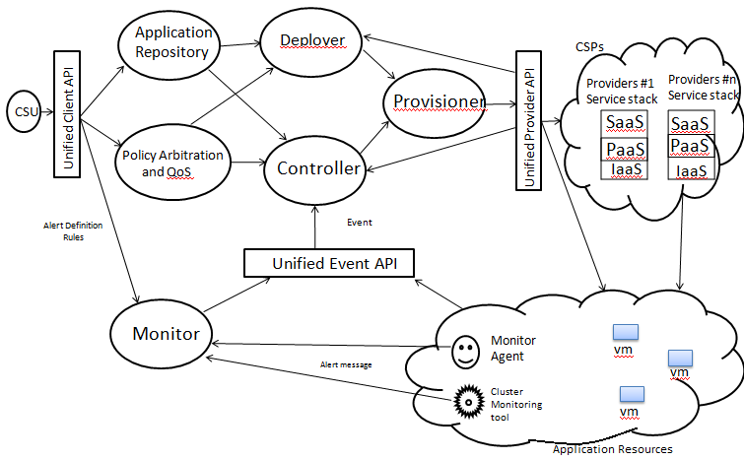
Figure 4.3Resource provisioning framework for application-centric cloud
4.3.1 Explanation:
- An application is run through different stages denoted by t;1 ≤ t ≤ T. The granularity of a stage is determined by the number of hours per stage (h).
- At every stage of execution of the application, its demand for resources is known (or estimated using the mechanisms described in ) and is denoted by the vector D.
- Since the reservation made at any particular time has a long term effect, in order to ﬁnd an optimal reservation schedule, the future value of demand for resources is to be known in advance.
- It is therefore assumed that the predicted values of the demand vector are available at each stage t, 1 ≤ t ≤ T. Resources can be reserved under different contracts (e.g. for a one-year contract or for a three-years contract).
- Reserved resources have a one-time ﬁxed charge for the duration of the contract and a variable usage charge at discounted rate to be paid on hourly basis.
- Resource instances can be reserved and launched at the beginning of a stage and can be terminated at the end of a stage.
- If the demand at a given stage t is more than the total amount of resources reserved, the balance requirement is satisﬁed with on-demand instances.
- For efficient utilization of resources and to minimize cost, a hybrid cloud scheduling algorithm is used for hybrid clouds. The need for hybrid cloud determines which workload type has to be outsourced and to which cloud service provider. These decisions should minimize the cost of running the part of the total workload on one or more multiple cloud providers which must take into account application requirement such as deadline constraint and data requirement.
- Resources have a one-time ﬁxed charge for the duration of the contract and a variable usage charge at discounted rate to be paid on hourly basis.
- Thus, the optimal resource reservation problem can be formally stated as
Given a vector of demands D for resources at different stages t, 1 ≤ t ≤ T, ﬁnd the number of resources to be reserved under different contracts at each stage t, so that the total cost is minimized satisfying the demands at every stage.

4.4 DATA FLOW DIAGRAM
A Dataflow diagram is a graphical aid for defining systems input, process and outputs. It represents flow of data through the system. DFD is one of the most important modelling jobs. It is used to model the systems components. It may be partitioned into levels that represent increasing information flow and functional details

Data flow design can be used to provide the end user with a physical idea of where the data they can input ultimately has an effect upon the structure of the whole System.
- Process:

Process is any function that been performed.


- External:

An External entity is a source or destination of Element

- Data flow :

Data flow shows the direction of data elements movement.

- Database:

Data base is used to store the data.
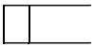

4.4 Data Flow Diagram:
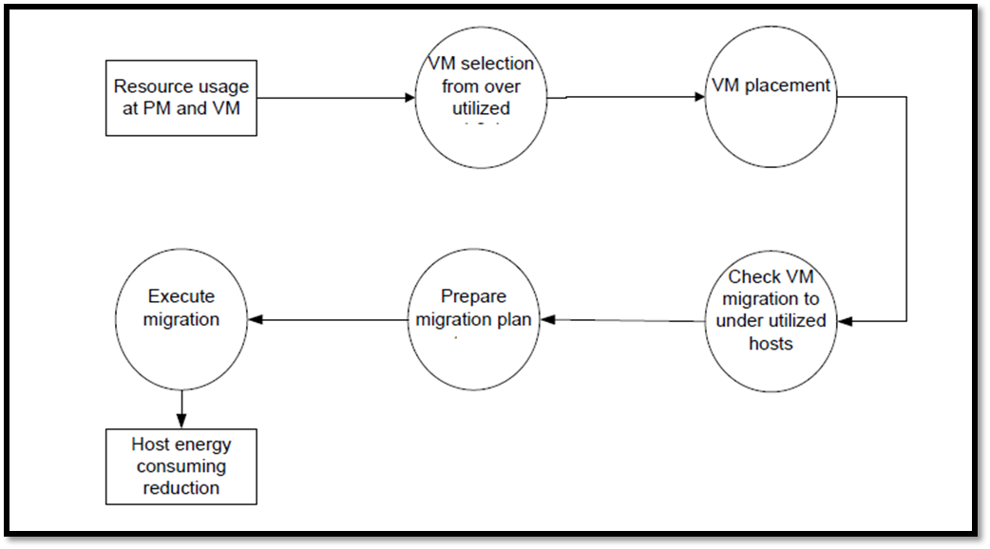
Figure4.4: Data Flow Diagram
Explanation:
Step 1: Resource usage is calculated for both process level machine & virtual level machine.
Step 2: process control goes to the Virtual Machine selection for over utilize resources.
Step 3: In this phase Virtual Machine placement done according to the resource plan.
Step 4: in the 4th Step checking Virtual Machine migration is conducted as per the plan.
Step 5: the migration is executed and the broker assigns the placements.
Step 6: in the last phase the host energy consumption is reduced accordingly.
4.4.1 INTRODUCTION TO UNIFIED MODELLING LANGUAGE
The Unified Modelling Language (UML) is a general-purpose, developmental, modelling language in the field of software engineering that is intended to provide a standard way to visualize the design of a system.
There are four parts to the UML 2.x specification:
- The Superstructure that defines the notation and semantics for diagrams and their model elements
- The Infrastructure that defines the core meta model on which the Superstructure is based
- The Object Constraint Language (OCL) for defining rules for model elements
- The UML Diagram Interchange that defines how UML 2 diagram layouts are exchanged
The current versions of these standards follow: UML Superstructure version 2.4.1, UML Infrastructure version 2.4.1, OCL version 2.3.1, and UML Diagram Interchange version 1.0. It continues to be updated and improved by the revision task force, who resolve any issues with the language

4.5 Design
The Unified Modeling Language (UML) offers a way to visualize a system's architectural blueprints in a diagram (see image), including elements such as:
- Any activities (jobs)
- Individual components of the system
- And how they can interact with other software components.
- How the system will run
- How entities interact with others (components and interfaces)
- External user interface
Although originally intended solely for object-oriented design documentation, Unified Modelling Language has been extended to cover a larger set of design documentation and been found useful in many contexts.

4.6 Software development methods

UML is not a development method by itself; however, it was designed to be compatible with the leading object-oriented software development methods of its time (for example OMT, Booch method, Objector) and especially with RUP that it was originally intended to be used when work began at Rational Software Inc.

4.7 Modeling
It is important to distinguish between the UML model and the set of diagrams of a system. A diagram is a partial graphic representation of a system's model. The set of diagrams need not completely cover the model and deleting a diagram does not change the model. The model may also contain documentation that drives the model elements and diagrams (such as written use cases).
UML diagrams represent two different views of a system model:
- Static (or structural) view: emphasizes the static structure of the system using objects, attributes, operations and relationships. The structural view includes class diagrams and composite structure diagrams.
- Dynamic (or behavioral) view: emphasizes the dynamic behavior of the system by showing collaborations among objects and changes to the internal states of objects. This view includes sequence diagrams, activity diagrams and state machine diagrams.
UML models can be exchanged among UML tools by using the XML Metadata Interchange (XMI) interchange format.
UML 2 has many types of diagrams, which are divided into two categories. Some types represent structural information, and the rest represent general types of behavior, including a few that represent different aspects of interactions
One of the purposes of UML was to provide the development community with a stable and common design language that could be used to develop and build computer applications. UML brought forth a unified standard modeling notation that IT professionals had been wanting for years.
Using UML, IT professionals could now read and disseminate system structure and Design plans -- just as construction workers have been doing for years with blueprints of buildings. Since UML is not a methodology, it does not require any formal work products (i.e., "artifacts" in IBM Rational Unified Process® lingo). Yet it does provide several types of diagrams that, when used within a given methodology, increase the ease of understanding an application under Development. There is more to UML than these diagrams, but for my purposes here, the diagrams offer a good introduction to the language and the principles behind its use. By placing standard UML diagrams in your methodology's work products, you make it easier for UML-proficient people to join your project and quickly become productive. The most useful,
Standard UML diagrams are: use case diagram, class diagram, sequence diagram, state chart diagram, activity diagram, component diagram, and deployment diagram. It is beyond the scope of this introductory article to go into great detail about each type of diagram. Instead, I will provide you with enough information for a general understanding of each one and then supply more details in later articles.

4.8 Structure diagrams
Structure diagrams emphasize the things that must be present in the system being modelled. Since structure diagrams represent the structure, they are used extensively in documenting the software architecture of software systems. For example, the component diagram describes how a software system is split up into components and shows the dependencies among these components.

4.8.1 Behaviour diagrams
Behaviour diagrams emphasize what must happen in the system being modelled. Since behaviour diagrams illustrate the behaviour of a system, they are used extensively to describe the functionality of software systems. As an example, the describes the business and operational step-by-step activities of the components in a system.

4.8.2 Interaction diagrams

Interaction diagrams, a subset of behaviour diagrams, emphasize the flow of control and data among the things in the system being modelled. For example, the sequence diagram shows how objects communicate with each other in terms of a sequence of messages. Meta modelling Main article: Meta-Object Facility
4.8.3 Illustration of the Meta-Object Facility
The Object Management Group (OMG) has developed a Meta modeling architecture to define the Unified Modeling Language (UML), called the Meta-Object Facility (MOF). The Meta-Object Facility is designed as a four-layered architecture, as shown in the image at right. It provides a meta-meta model at the top layer, called the M3 layer. This M3-model is the language used by Meta-Object Facility to build met models, called M2-models.
The most prominent example of a Layer 2 Meta-Object Facility model is the UML met model, the model that describes the UML itself. These M2-models describe elements of the M1-layer, and thus M1-models. These would be, for example, models written in UML. The last layer is the M0-layer or data layer. It is used to describe runtime instances of the system.
The meta-model can be extended using a mechanism which is called stereotyping.
7.4.2 Class diagram
The class diagram shows how the different entities (people, things, and data) relate to each other; in other words, it shows the static structures of the system. A class diagram can be used to display logical classes, which are typically the kinds of things the business people in an organization talk about -- rock bands, CDs, radio play; or loans, home mortgages, car loans, and interest rates. Class diagrams can also be used to show implementation classes, which are the things that programmers typicallydeal with.
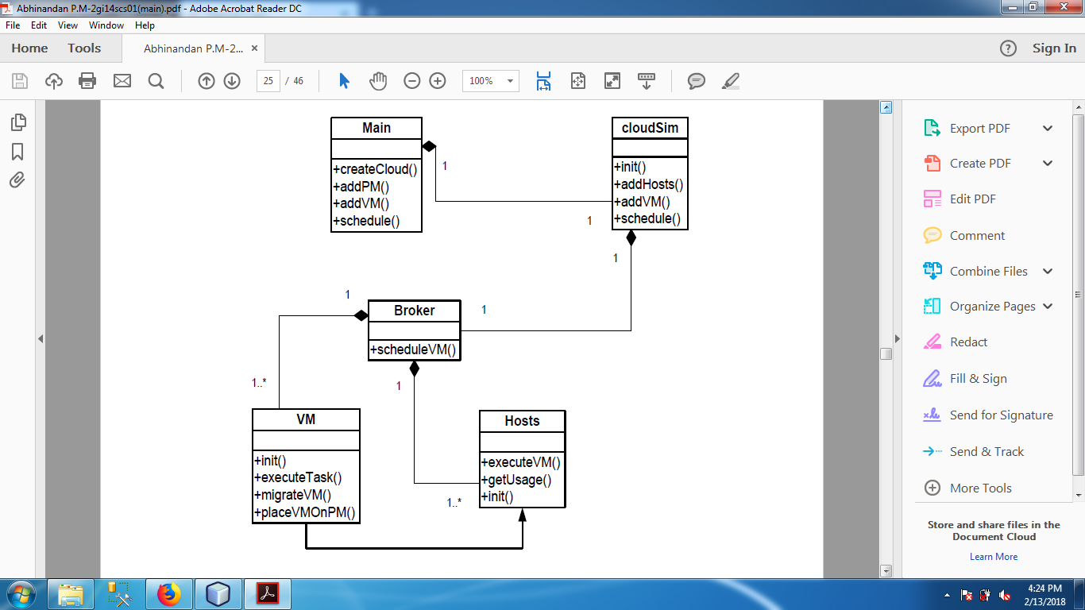
An implementation class diagram will probably show some ofthe same classes as the logical class’s diagram. The implementation classdiagram won't be drawn with the same attributes, however, because it will most likely have references to things like Vectors and Hash.

UNIFIED MODELING DIAGRAM:

Figure 7.1: Unified modeling diagram

Figure 4.8.3: Unified modeling diagram
4.9 Use Case Diagram:
The system involves a set of actors and cases. Each use case represents a piece of functionality that the use case shows. Use case shows the functionality of the system. Each actor represents object of the system. The actor of the system represents the complete set of objects that the system can give. Objects create the behavior from the system with which they interact as actor.
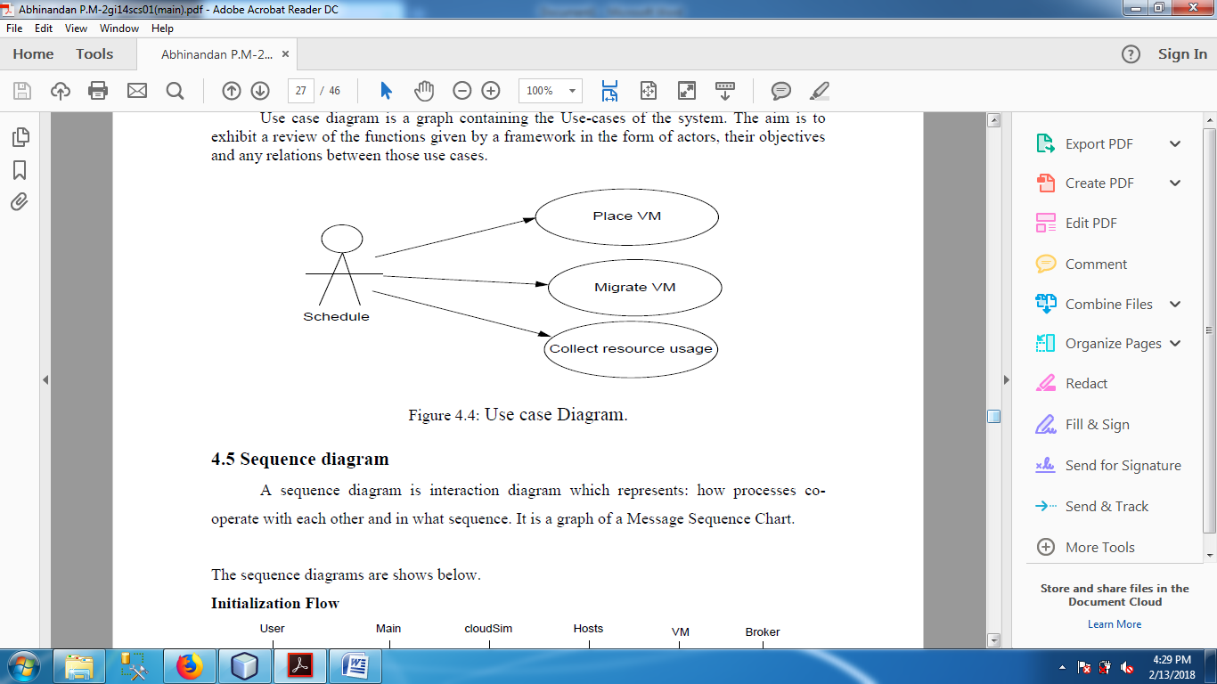
Figure 4.9 : Use Case
4.10 System Requirement

    - Hardware Requirement

PROCESSOR : Dual core or above
RAM : 1GB Min
HARD DISK : 5 GB min
    - Software Requirement

OPERATING SYSTEM : Windows 7 or higher
SERVER SIDE SCRIPTING : Java
CLIENT SIDE SCRIPTING : Java Swing

CHAPTER 5
TECHNICAL SPECIFICATION
5.1. INTRODUCTION TO JAVA
Java is a general-purpose computer-programming language that is concurrent, class-based, object-oriented, and specifically designed to have as few implementation dependencies as possible. It is intended to let application developers "write once, run anywhere" (WORA),meaning that compiled Java code can run on all platforms that support Java without the need for recompilation. Java applications are typically compiled to byte code that can run on any Java virtual machine (JVM) regardless of computer architecture. As of 2016, Java is one of the most popular programming languages in use, particularly for client-server web applications, with a reported 9 million developers. Java was originally developed by James Gosling at Sun Microsystems(which has since been acquired by Oracle Corporation) and released in 1995 as a core component of Sun Microsystems' Java platform. The language derives much of its syntax from C and C++, but it has fewer low-level facilities than either of them.
Mike Sheridan, and Patrick Naught on initiated the Java language project in June 1991.Java was originally designed for interactive television, but it was too advanced for the digital cable television industry at the time. The language was initially called Oak after an oak tree that stood outside Gosling's office. Later the project went by the name Green and was finally renamed Java, from Java coffee. Gosling designed Java with a C/C++-style syntax that system and application programmers would find familiar.
Sun Microsystems released the first public implementation as Java 1.0 in 1995. It promised "Write Once, Run anywhere" (WORA), providing no-cost run-times on popular platforms. Fairly secure and featuring configurable security, it allowed network- and file-access restrictions. Major web browsers soon incorporated the ability to run Java applets within web pages, and Java quickly became popular. The Java 1.0 compiler was re-written in Java by Arthur van Hoff to comply strictly with the Java 1.0 language specification. With the advent of Java 2 (released initially as J2SE 1.2 in December 1998 – 1999), new versions had multiple configurations built for different types of platforms. J2EE included technologies and APIs for enterprise applications typically run in server environments, while J2ME featured APIs optimized for mobile applications. The desktop version was renamed J2SE. In 2006, for marketing purposes, Sun renamed new J2 versions as Java EE, Java ME, and Java SE, respectively.
In 1997, Sun Microsystems approached the ISO/IEC JTC 1 standards body and later the Ecma International to formalize Java, but it soon withdrew from the process. Java remains a de facto standard, controlled through the Java Community Process.] At one time, Sun made most of its Java implementations available without charge, despite their proprietary software status. Sun generated revenue from Java through the selling of licenses for specialized products such as the Java Enterprise System.
On November 10, 2006, Sun released much of its Java virtual machine (JVM) as free and open-source software, (FOSS), under the terms of the GNU General Public License (GPL). On May 8, 2007, Sun finished the process, making all of its JVM's core code available under free software/open-source distribution terms, aside from a small portion of code to which Sun did not hold the copyright.
Sun's vice-president Rich Green said that Sun's ideal role with regard to Java was as an "evangelist". Following Oracle Corporation's acquisition of Sun Microsystems in 2009–10, Oracle has described itself as the "steward of Java technology with a relentless commitment to fostering a community of participation and transparency". This did not prevent Oracle from filing a lawsuit against Google shortly after that for using Java inside the Android SDK (see Google section below). Java software runs on everything from laptops to data centers, game consoles to scientific super computers. On April 2, 2010, James Gosling resigned from Oracle.
Oracle Corporation is the current owner of the official implementation of the Java SE platform, following their acquisition of Sun Microsystems on January 27, 2010. This implementation is based on the original implementation of Java by Sun. The Oracle implementation is available for Microsoft Windows (still works for XP, while only later versions are currently officially supported), macOS, Linux, and Solaris. Because Java lacks any formal standardization recognized by Ecma International, ISO/IEC, ANSI, or other third-party standards organization, the Oracle implementation is the de facto standard.
5.1.1 Java Identifiers
All Java components require names. Names used for classes, variables, and methods are called identifiers
There are several points to remember about identifiers
- All identifiers should begin with a letter (A to Z or a to z), currency character ($) or an underscore (_).
- After the first character, identifiers can have any combination of characters.
- A key word cannot be used as an identifier.
- Most importantly, identifiers are case sensitive.
- Examples of legal identifiers: age, $salary, _value, __1_value.
5.1.2Java Modifiers
It is possible to modify classes, methods, etc., by using modifiers.
There are two categories of modifiers:
- Access Modifiers:- default, public , protected, private
- Non-access Modifiers:- final, abstract, strictfp
5.1.3 Java Variables
A variable is defined by the combination of an identifier, a type, and an optional initialize. In addition, all variables have a scope, which defines their visibility, and a lifetime.
Declaring a Variable
In Java, all variables must be declared before they can be used. The basic form of a variable.
Declaration is shown here: type identifier [ = value][, identifier [= value] ...] ;
There are three kinds of variables in Java:-
- Local variables
- Instance variables
- Class/static variables
Local variables:-
- Local variables are declared in methods, constructors, or blocks.
- Access modifiers cannot be used for local variables.
- Local variables are visible only within the declared method, constructor or block.
Instance variables:-
- Instance variables are declared in a class, but outside a method, constructor or any block.
- When a space is allocated for an object in the heap, a slot for each instance variable value is created.
- Instance variables can be declared in class level before or after use.
- Access modifiers can be given for instance variables.
Class/static variables:-
- Class variables also known as static variables are declared with the static keyword in a class, but outside a method, constructor or a block.
- Static variables are rarely used other than being declared as constants. Constants are variables that are declared as public/private, final and static. Constant variables never change from their initial value.
- Static variables are created when the program starts and destroyed when the program stops.

5.1.4Java Swings:
Swing is a GUI widget toolkit for Java. It is part of Oracle's Java Foundation Classes (JFC) – an API for providing a graphical user interface (GUI) for Java programs.
Swing was developed to provide a more sophisticated set of GUI components than the earlier Abstract Window Toolkit (AWT). Swing provides a look and feel that emulates the look and feel of several platforms, and also supports a feel that allows applications to have a look and feel unrelated to the underlying platform. It has more powerful and flexible components than AWT. In addition to familiar components such as buttons, check boxes and labels, Swing provides several advanced components such as tabbed panel, scroll panes, trees, tables, and lists.
Unlike AWT components, Swing components are not implemented by platform-specific code. Instead, they are written entirely in Java and therefore are platform-independent. The term "lightweight" is used to describe such an element.
Though Swing is intended to be replaced by JavaFX, it will remain part of the Java SE specification for the foreseeable future.
Swing is a platform-independent, "model-view-controller" GUI framework for Java, which follows a single-threaded programming model. Additionally, this framework provides a layer of abstraction between the code structure and graphic presentation of a Swing-based GUI.
Swing provides a richer set of components than AWT. They are 100% Java-based.
AWT on the other hand was developed with the mindset that if a component or capability of a component wasn't available on one platform, it won't be available on any platform. Something quickly portable from platform x, to y, to z. Due to the peer-based nature of AWT, what might work on one implementation might not work on another, as the peer-integration might not be as robust. Many of the original AWT problems were traceable to differences in peer implementations.

Advantages:
- Swing provides both additional components and added functionality to AWT-replacement components
- Swing components can change their appearance based on the current "look and feel" library that's being used. You can use the same look and feel as the platform you're on, or use a different look and feel
- Swing components follow the Model-View-Controller paradigm (MVC), and thus can provide a much more flexible UI.
- Swing provides "extras" for components, such as
- Icons on many components.
- Decorative border for components.
- Tooltips for components.
- Swing components are light weight(less resource intensive then AWT)
- Swing provides built-in double buffering
- Swing provides paint dubbing support for when you build your own components
- This is not to say that there are fewer bugs in Swing, though most are out these days. It’s just that if a bug exists in Swing, it’s the same problem on all platforms, which was not the case with AWT.
- Swing is a platform-independent, "model-view-controller" GUI framework for Java, which follows a single-threaded programming model.
- Additionally, this framework provides a layer of abstraction between the code structure and graphic presentation of a Swing-based GUI.

5.2 INTRODUCTION TO NETBEANS IDE
NetBeans began in 1996 as Xelfi (word play on Delphi), a Java IDE student project under the guidance of the Faculty of Mathematics and Physics at Charles University in Prague. In 1997, Roman Staněk formed a company around the project and produced commercial versions of the NetBeans IDE until it was bought by Sun Microsystems in 1999. Sun open-sourced the NetBeans IDE in June of the following year. Since then, the NetBeans community has continued to grow. In 2010, Sun (and thus NetBeans) was acquired by Oracle Corporation. Under Oracle, NetBeans competed with JDeveloper, a freeware IDE that has historically been a product of the company. In September 2016, Oracle submitted a proposal to donate the NetBeans project to the Apache Software Foundation, stating that it was "opening up the NetBeans governance model to give NetBeans constituents a greater voice in the project's direction and future success through the upcoming release of Java 9 and NetBeans 9 and beyond". The move was endorsed by Java creator James Gosling. The project entered the Apache Incubator in October 2016.
NetBeans IDE is an open-source integrated development environment. NetBeans IDE supports development of all Java application types (Java SE (including JavaFX), Java ME, web, EJB and mobile applications) out of the box. Among other features are an Ant-based project.
5.2.1 NetBeans IDE releases:
NetBeans IDE 6.0 introduced support for developing IDE modules and rich client applications based on the NetBeans platform, a Java Swing GUI builder (formerly known as "Project Matisse"), improved CVS support, WebLogic 9 and JBoss 4 support, and many editor enhancements. NetBeans 6 is available in official repositories of major Linux distributions.
NetBeans IDE 6.5, released in November 2008, extended the existing Java EE features (including Java Persistence support, EJB 3 and JAX-WS). Additionally, the NetBeans Enterprise Pack supports the development of Java EE 5 enterprise applications, including SOA visual design tools, XML schema tools, web services orchestration (for BPEL), and UML modeling. The NetBeans IDE Bundle for C/C++ supports C/C++ and FORTRAN development.
NetBeans IDE 6.8 is the first IDE to provide complete support of Java EE 6 and the GlassFish Enterprise Server v3. Developers hosting their open-source projects on kenai.com additionally benefit from instant messaging and issue tracking integration and navigation right in the IDE, support for web application development with PHP 5.3 and the Symfony framework, and improved code completion, layouts, hints and navigation in JavaFX projects.
NetBeans IDE 6.9, released in June 2010, added support for OSGi, Spring Framework 3.0, Java EE dependency injection (JSR-299), Zend Framework for PHP, and easier code navigation (such as "Is Overridden/Implemented" annotations), formatting, hints, and refactoring across several languages.
NetBeans IDE 7.0 was released in April 208. On August 1, 208, the NetBeans Team released NetBeans IDE 7.0.1, which has full support for the official release of the Java SE 7 platform.
NetBeans IDE 7.3 was released in February 2010 which added support for HTML5 and web technologies.
NetBeans IDE 7.4 was released on October 15, 2010.
NetBeans IDE 8.0 was released on March 18, 2014.
NetBeans IDE 8.1 was released on November 4, 2015.
NetBeans IDE 8.2 was released on October 3, 2016.
Netbeans 9.0, which adds support for Java 9, is currently in development by the Apache Incubator project.
5.2.2 NetBeans Platform:
The NetBeans Platform is a framework for simplifying the development of Java Swing desktop applications. The NetBeans IDE bundle for Java SE contains what is needed to start developing NetBeans plugins and NetBeans Platform based applications; no additional SDK is required.
Applications can install modules dynamically. Any application can include the Update Center module to allow users of the application to download digitally signed upgrades and new features directly into the running application. Reinstalling an upgrade or a new release does not force users to download the entire application again.
The platform offers reusable services common to desktop applications, allowing developers to focus on the logic specific to their application. Among the features of the platform are:
- User interface management (e.g. menus and toolbars)
- User settings management
- Storage management (saving and loading any kind of data)
- Window management
- Wizard framework (supports step-by-step dialogs)
- NetBeans Visual Library
- Integrated development tools
Applications can install modules dynamically. Any application can include the Update Center module to allow users of the application to download digitally signed upgrades and new features directly into the running application. Reinstalling an upgrade or a new release does not force users to download the entire application again.
Modularity: All the functions of the IDE are provided by modules. Each module provides a well-defined function, such as support for the Java language, editing, or support for the CVS versioning system, and SVN. NetBeans contains all the modules needed for Java development in a single download, allowing the user to start working immediately. Modules also allow NetBeans to be extended. New features, such as support for other programming languages, can be added by installing additional modules. For instance, Sun Studio, Sun Java Studio Enterprise, and Sun Java Studio Creator from Sun Microsystems are all based on the NetBeans IDE.

5.3 INTRODUCTION TO CLOUDSIM
5.3.1 Introduction:
Cloudsim provides a generalized and extensible simulation framework that enables modeling, simulation and experimentation of emerging Cloud Computing infrastructure and application services. Cloud computing is Internet-based computing, whereby shared resources, software, and information are provided to computers and other devices on demand, like the electricity grid. Recently, cloud computing emerged as the leading technology for delivering reliable, secure, fault-tolerant, sustainable, and scalable computational services, which are presented as Software, Infrastructure, or Platform as services (SaaS, IaaS, PaaS). Moreover, these services may be offered in private data centers (private clouds), may be commercially offered for clients (public clouds), or yet it is possible that both public and private clouds are combined in hybrid clouds.
5.3.1.1Service based model - aim to simulate
- Infrastructure as a Service (IaaS)
- Platform as a Service (PaaS)
- Software as a Service (SaaS)
1) Infrastructure as a Service (IaaS):
Hardware is provided by an external provider and managed for you.
2) Platform as a Service (PaaS):
The capability provided to the consumer is to deploy onto the cloud infrastructure consumer-created or acquired applications created using programming languages and tools supported by the provider. E.g.: Google App Engine & Hadoop.

3) Software as a Service (SaaS):
The capability provided to the consumer is to use the provider’s applications running on a cloud infrastructure. The applications are accessible from various client devices through a thin client interface such as a web browser (e.g., web-based email).
5.3.1.2Cloud Deployment Model – Ownership and paying model
- Public Clouds
- Community Clouds
- Private Clouds
- Hybrid Clouds
5.3.1.3 Public Cloud:
The cloud infrastructure is made available to the general public or a large industry group and is owned by an organization selling cloud services.
5.3.1.4 Community Cloud:
The cloud infrastructure is shared by several organizations and supports a specific community that has shared concerns (e.g., mission, security requirements, policy and compliance considerations).
5.3.1.5 Private Cloud:
The cloud infrastructure is operated solely for an organization. It may be managed by the organization or a third party and may exist on premise or off premise.
5.3.1.6 Hybrid Cloud:
The cloud infrastructure is a composition of two or more clouds (private, community, or public) that remain unique entities but are bound together by standardized or proprietary technology that enables data and application portability (e.g., cloud bursting for load-balancing between clouds).
5.3.3 What Is Cloudsim ?
Motivation provides a generalized and extensible simulation framework that enables modeling, simulation and experimentation of emerging Cloud Computing infrastructure and application services. CloudSim is developed in the CLOUDS Laboratory, at the Computer Science and Software Engineering Department of the University of Melbourne. CloudSim Toolkit 3.0 released at Jan 10, 209.

5.3.4 Main features:
Overview of CloudSim functionalities:
- support for modeling and simulation of large scale Cloud computing data centers
- support for modeling and simulation of virtualized server hosts, with customizable policies for provisioning host resources to virtual machines
- support for modeling and simulation of application containers
- support for modeling and simulation of energy-aware computational resources
- support for modeling and simulation of data center network topologies and message-passing applications
- support for modeling and simulation of federated clouds
- support for dynamic insertion of simulation elements, stop and resume of simulation
- support for user-defined policies for allocation of hosts to virtual machines and policies for allocation of host resources to virtual machines
CloudSim Automation is a Java command line tool based on CloudSim and Cloud Reports classes that is able to read specifications of CloudSim simulation scenarios from a YAML file, a very human readable data format. Simulation scenarios can be written inside a YAML file and Cloud Automation Tool reads these simulation scenarios, creates and runs them on CloudSim. The tool releases researchers of the need to write Java code just to run simulation scenarios. By this way, the attention can be focused on the problem to be solved, such as creation of new algorithms to load balancing, new virtual machine scheduling policies, VM placement, resource provisioning, workload prediction, server consolidation, energy efficiency, cost reduction and so on.

5.3.5 Applications of Cloudsim:
- With the growing popularity and importance of Cloud computing, several external researchers around the world have started using CloudSim.
- For instance, HP Labs (Palo Alto) researchers are using CloudSim for evaluation of resource allocation algorithms for HP’s Cloud data centres.
- Duke University (U.S.A.) researchers are using it for energy-efficient management of data centres.
- China East Jiao Tong University researchers are using CloudSim for evaluating design and application scheduling in Clouds
- National Research Centre for Intelligent Computer Systems (Beijing, China) researchers are using it for SLA-oriented management and optimization of Cloud computing environments.
- Kookmin University (Seoul, Korea) researchers are using the toolkit for their investigation on workflow scheduling in Clouds.
- to use a human readable file format to specify cloud simulation scenarios and speed up such a simulation process phase.
5.3.6Cloud Services:
- VM Provisioning: The process of creating VM instances on hosts.
- CPU allocation: CPU is allocated to each of the services.
- Memory allocation: Memory is allocated to the host.
- Storage allocation: Storing of data or service is managed.
- Bandwidth allocation: This is an abstract class that models the policy for provisioning of bandwidth to VMs.
5.3.7Cloudsim In Social Networking:
- Cloud analyst is a tool developed at the University of Melbourne whose goal is to support the evaluation of social network applications, such as FaceBook, according to the geographic distribution of users and data centres.
- In this tool, communities of users and data centres supporting the social networks are characterized based on their location and other parameters such as user experience while using the social network application.
- The load on the data centre is continuously recorded in the form of logs.
- Apart from data storage, the social networks are now also using clouds for various other tasks. For example, this can be ideal for big data analytics. One of the benefits of using cloud systems is that users can access vast amount of structured and even non-structured data easily. You must have noticed the much-improved analytics provided by sites like Facebook, especially for its business users.
- Another way cloud computing becomes helpful is by reducing the cost of data backup and recovery in case of a disaster.

5.4 INTRODUCTION TO WAMP
WampServer refers to a software stack for the Microsoft Windows operating system, created by Romain Bourdon and consisting of the Apache web server, OpenSSL for SSL support, MySQL database and PHP programming language.
5.4.1 What is WAMP?
Stands for "Windows, Apache, MySQL, and PHP." WAMP is a variation of LAMP for Windows systems and is often installed as a software bundle (Apache, MySQL, and PHP). It is often used for web development and internal testing, but may also be used to serve live websites. The most important part of the WAMP package is Apache (or "Apache HTTP Server") which is used run the web server within Windows. By running a local Apache web server on a Windows machine, a web developer can test webpages in a web browser without publishing them live on the Internet.
WAMP also includes MySQL and PHP, which are two of the most common technologies used for creating dynamic websites. MySQL is a high-speed database, while PHP is a scripting language that can be used to access data from the database. By installing these two components locally, a developer can build and test a dynamic website before publishing it to a public web server. While Apache, MySQL, and PHP are open source components that can be installed individually, they are usually installed together. One popular package is called "WampServer," which provides a user-friendly way to install and configure the "AMP" components on Windows.
NOTE: The "P" in WAMP can also stand for either Perl or Python, which are other scripting languages. The Mac version of LAMP is known as MAMP.
Acronym for Windows/Apache/MySQL/PHP, Python, (and/or) PERL
The acronym WAMP refers to a set of free (open source) applications, combined with Microsoft Windows, which are commonly used in Web server environments. The WAMP stack provides developers with the four key elements of a Web server: an operating system, database, Web server and Web scripting software. The combined usage of these programs is called a server stack. In this stack, Microsoft Windows is the operating system (OS), Apache is the Web server, MySQL handles the database components, while PHP, Python, or PERL represents the dynamic scripting languages.
5.4.2 What is WAMP used for?
- WAMP is full form of software stack named Windows, Apache, MYSQL, PHP. It is variation of LAMP for Windows. It is used for testing webpages without publishing them live on the internet. In short it is used for off-line preview of webpages so developer can easily get idea to how their webpage looks on real web browser.
- It is a package used by PHP developers to develop their web projects on their local windows system. It comes with Apache server , MySQL database , PHPMyAdmin and PHP creating a suitable environment to development.
- Wamp, or wampserver, is a software that allows you to use your computer as a local server, and "host" websites on it. It is a very useful tool to check how your website would work on a dedicated server, especially for back-end aspects, like PHP and MySQL
5.4.3 What Is The Advantage Of WampServer?
Wamp server is a collection of programs you can use to turn your regular desktop PC to a fully compatible web server with HTTP, PHP, MySQL, PHPMyAdmin, SQLBuddy applications. The advantage is that it is easy configurable with the built-in tools. Also it is structured in the way that you have everything you need at a click distance. The configuration screens provide extra information how settings should look like. Another thing would be that the packed applications are configured to be compatible between them, all being automatic configured, you just unpack your script, database, application, run the installer (if it has any) and that's it.

5.5 INTRODUCTION TO XAMPP
XAMPP is a free and open source cross-platform web server solution stack package developed by Apache Friends, consisting mainly of the Apache HTTP Server, MariaDBdatabase , and interpreter for scripts written in the PHP and Perl programming languages. XAMPP stands for Cross-Platform(X), Apache (A), MariaDB(M), PHP(P), and Perl(P). It is a simple, lightweight Apache distribution that makes it extremely easy for developers to create a local web server for testing purpose. Everything needed to set up a web server-server (Apache), database (MariaDB), and scripting language (PHP)-is included in a extractable file. XAMPP is also Cross-platform, which means it works equally well on Linux, Mac and Windows. Since most actual web server deployment use the same components as XAMPP, it makes transitioning from a local test server to a live server extremely easy as well.
The term XAMPP is an apparent acronym. However , there is no official acronym expansion specified on the Apache friends website. Their homepage header reads “XAMPP Apache + MariaDB + PHP + Perl” , indicating that this abbreviation n is a recursive acronym.
XAMPP stands for Cross-Platform(X), Apache (A), MySQL (M), PHP(P), and Perl(P). It is a simple, lightweight Apache distribution that makes it extremely easy for developers to create a local web server for testing purpose. Everything you need to set up a web server-server (Apache), database (MariaDB), and scripting language (PHP)-is included in a extractable file. XAMPP is also Cross-platform, which means it works equally well on Linux, Mac and Windows. Since most actual web server deployment use the same components as XAMPP, it makes transitioning from a local test server to a live server extremely easy as well.
5.5.1 Features
XAMPP is regularly updated to incorporate the latest releases of Apache ,MariaDB, PHP and Perl. It is also comes with a number of other modules including OpenSSL, phpMyAdmin, MediaWiki, Joomla, Word Press and more. Self-contained, multiple instances of XAMPP can exist on a single computer, and any given instance can be copied from one computer to another. XAMPP is offered in both a full and a standard version (Smaller version).
5.5.2 Usage
Officially, XAMPP’s designers intended it for use only as a development tool, to allow website designers and programmers to test own their work on their computers without any access to the Internet. To make this as easy as possible, many important security features are disabled by default. XAMPP has the ability to serve web pages on World Wild Web. A special tool is provided to password-protect the most important parts of the package. XAMPP also provides support for creating and manipulating databases in MariaDB and SQLite among others.
5.5.3 Installation Considerations
- You can choose to run any of the XAMPP components asa service. This means the components will start/stop in parallel with the start-up/shut-down of your machine (works only on 32bitkernel Windows operating system). This does not have anything to dowith your registry; however, we will not be describing the use running components as services; instead, we tackle things here the tried and trusted way-via the command prompt.
- XMAPP requires port 80 to work. If you already have a server occupying port 80 (e.g. ColdFusion Server, IIS server, etc.), you will not be able to lunch XAMPP after installing it due to a port-binding conflict. The safest (albeit perhaps not the most convenient) solution is uninstall whatever system/application that is already binding the port. IIS Server is often a common culprit because it’s already a part of your PC; so if you have a port-binding conflict, see if you need to disable IIS Server on your system.
- Warning: Using a local install of XAMPP as a production server with access Internet is a very bad idea (unless you simply enjoy endless fighting with people trying to hack into yoursystem). Use XAMPP as a local development server only! Also keep in mind that a local install of XAMPP does not emulate a live server environment,but rather is simply a good, quick, and easy solution for designers to develop quietly. If your project involves integrating other application into Textpattern, you may run into problems (out of scope here); however, most third-party Text pattern plug-ins work fine (none have been discovered --or announced – yet that do not).
- If you are using Win XP, then after installing the packages you may see your WindowsFirewall system indicate that some utilities and/or files are blocked (e.g. the Apache server itself). Again, do not use a local install for production purposes (development only), go ahead and unblock the indicated utilities and/or files.
5.5.4 What’s including in XAMPP?
Xampp has four components. There are:
- Apache: Apache is the actual web server application that processes and delivers web content to a computer. Apache is the most popular web server online. powering nearly 54% of all websites.
- MySQL: Every web application.howso ever simple or complicated. Requires a database for storing collecting data. MySQL which is open source. Is the world’s most popular database management system. It powers everything from hobbyist websites to professional platforms like Word Press. You can learn how to master PHP with this free MySQL. Database for beginners course.
- PHP: PHP stands for Hypertext Pre-processor. It is a server-side scripting language that powers some of the most popular websites in the world, including Word Press and Facebook. It is open source, relatively easy to learn, and works perfectly with MySQL, making it a popular choice for web developers.
- Perl: Perl is a high-level dynamic programming language used extensively in network programming system admin, etc. although less popular for web developer purpose, Perl has a lot of niche applications.
Different versions of xampp may have additional components such as php My Admin. Openssl,etc. to create full-fledged web servers.

CHAPTER 6
6. CODING
6.1HeristicOptOnDemandCmplx.java
private static List<Cloudlet> createCloudletList(int userId, int nb_cloudlet, int IdShift , int type_cl) {
List<Cloudlet> list = new ArrayList<>();
long[] length= {5000,4486,299,2315};
int pesNumber=1;
long fileSize = 300;
long outputSize = 300;
int offset = no_cur_cloudlet;
System.out.println("IdShift = " + IdShift );
for (int i = no_cur_cloudlet ; i < (offset+nb_cloudlet) ; i++)
{
Cloudlet cloudlet = new Cloudlet((IdShift+i), length[type_cl], pesNumber, fileSize, outputSize, new UtilizationModelFull(), new UtilizationModelFull(), new UtilizationModelFull());
cloudlet.setUserId(userId);
cloudlet.setVmId((IdShift+i));
list.add(cloudlet);
no_cur_cloudlet++;
System.out.println("Cloudlet created // No de Cloudlet = "+ no_cur_cloudlet +" // Cloudlet List Size = " + list.size());
}
return list;
}
public static void UpdateCloudletList(List<Cloudlet> list_)
{
cloudletList.addAll(list_);
}
private static List<Vm> createVms(int userId, int nb_vm, int IdShift , int type_vm) {
List<Vm> vms = new ArrayList<>();

// VM description
int [] mips={50,75,150,75} ;
int pesNumber = 1; // number of cpus
int ram = 98; // vm memory (MB)
long bw = 2500; // bandwidth
long size = 2500; // image size (MB)
String vmm= "Xen"; // VMM name

System.out.println(no_cur_vm + "//" + nb_vm);
int offset=no_cur_vm;
for (int i = no_cur_vm ; i < (offset+nb_vm); i++) {
vms.add(
new Vm((IdShift+i), userId, mips[type_vm], pesNumber, ram, bw, size, vmm, new CloudletSchedulerSpaceShared())
);
no_cur_vm++;
System.out.println("VM created // No VM = "+ no_cur_vm +" // List Vm size = " + vms.size() + " // ID Shift+1 = " + (IdShift+i) + "id vm = " + vms.get(0).getId());
}
return vms;
}
public static void UpdateVmList(List<Vm> list_)
{
vmList.addAll(list_);
}
private static PowerDatacenter createDatacenter(String name) throws Exception
{
List<PowerHost> hostList = new ArrayList<>();
double maxPower = 250; // 250W
double staticPowerPercent = 0.7; // 70%
int mips=2500;;
int ram = 10000; // host memory (MB)
long storage = 1000000; // host storage
int bw =300000;
boolean enableDVFS = true;
ArrayList<Double> freqs = new ArrayList<>(); // frequencies available by the CPU
freqs.add(59.925);// frequencies are defined in % , it make free to use Host MIPS like we want.
freqs.add(69.93); // frequencies must be in increase order !
freqs.add(79.89);
freqs.add(89.89);
freqs.add(100.0);
HashMap<Integer,String> govs = new HashMap<Integer,String>(); // Define wich governor is used by each CPU
govs.put(0,"ondemand");
for (int i = 0; i < hostsNumber; i++) {

//HostDatas tmp_host = vect_hosts.get(i);

HeuristicCostOpt = new DvfsDatas();
HashMap<String,Integer> tmp_HM_OnDemand = new HashMap<>();
tmp_HM_OnDemand.put("up_threshold",95);
tmp_HM_OnDemand.put("sampling_down_factor",100);
HashMap<String,Integer> tmp_HM_Conservative = new HashMap<>();
tmp_HM_Conservative.put("up_threshold",80);
tmp_HM_Conservative.put("down_threshold",20);
tmp_HM_Conservative.put("enablefreqstep",0);
tmp_HM_Conservative.put("freqstep",5);
HashMap<String,Integer> tmp_HM_UserSpace = new HashMap<>();
tmp_HM_UserSpace.put("frequency",3);
HeuristicCostOpt.setHashMapOnDemand(tmp_HM_OnDemand);
HeuristicCostOpt.setHashMapConservative(tmp_HM_Conservative);
HeuristicCostOpt.setHashMapUserSpace(tmp_HM_UserSpace);
List<Pe> peList = new ArrayList<Pe>();
int nb_pe = 1 ;
System.out.println("Number of CPU : " + nb_pe );
for(int pe=0 ; pe < nb_pe ; pe++)
{
peList.add(new Pe(pe, new PeProvisionerSimple(mips),freqs,govs.get(pe), HeuristicCostOpt));
}
hostList.add(
new PowerHost(
i,
new RamProvisionerSimple(ram),
new BwProvisionerSimple(bw),
storage,
peList,
new VmSchedulerTimeShared(peList),
new PowerModelSpecPower_BAZAR(peList),false,
enableDVFS
)
); // This is our machine
}
String arch = "x86"; // system architecture
String os = "Linux"; // operating system
String vmm ="Xen";
double time_zone = 10.0; // time zone this resource located
double cost = 3.0; // the cost of using processing in this resource
double costPerMem = 0.05; // the cost of using memory in this resource
double costPerStorage = 0.001; // the cost of using storage in this resource
double costPerBw = 0.0; // the cost of using bw in this resource

DatacenterCharacteristics characteristics = new DatacenterCharacteristics(
arch, os, vmm, hostList, time_zone, cost, costPerMem, costPerStorage, costPerBw);

// 6. Finally, we need to create a PowerDatacenter object.
PowerDatacenter powerDatacenter = null;
try {
powerDatacenter = new PowerDatacenter(
name,
characteristics,
new PowerVmAllocationPolicySimpleWattPerMipsMetric(hostList),
new LinkedList<Storage>(),
0.01); // fix to 0.1
} catch (Exception e) {
e.printStackTrace();
}
return powerDatacenter;
}
public void processEvent(SimEvent ev)
{
List<Vm> vmList = null;
int type_vm;
int type_cl;

switch (ev.getTag())
{
case STEP_1:
type_vm = 0;
type_cl = 0;

if(no_broker==21)
setBroker(createBrokerWithEvent("Broker_"+no_broker, new EventPostBroker(getId(), STEP_2) ));
else
setBroker(createBroker("Broker_"+no_broker));

System.out.println("Add a Vm and a Cloudlet... IdBroker=" + getBroker().getId());

vmList_=createVms(getBroker().getId(), 1, (no_broker*100) , type_vm);
UpdateVmList(vmList_);
cloudletList_=createCloudletList(getBroker().getId(), 1,
(no_broker*100),type_cl);
UpdateCloudletList(cloudletList_);

broker.submitVmList(getVmList());
broker.submitCloudletList(getCloudletList());

no_broker++;
if(no_broker<49)
schedule(getId(), 1, STEP_1);
CloudSim.resumeSimulation();

break;

case STEP_2:
type_vm = 1;
type_cl = 1;

setBroker(createBrokerWithEvent("Broker_"+no_broker , new EventPostBroker(getId(), STEP_3) ));

System.out.println("Add a Vm and a Cloudlet... IdBroker=" + getBroker().getId());

vmList_=createVms(getBroker().getId(), 10, (no_broker*100), type_vm);
UpdateVmList(vmList_);
cloudletList_=createCloudletList(getBroker().getId(), 10, (no_broker*100),type_cl);
UpdateCloudletList(cloudletList_);

broker.submitVmList(getVmList());
broker.submitCloudletList(getCloudletList());
CloudSim.resumeSimulation();

break;
case STEP_3:
type_vm = 2;
type_cl = 2;
no_broker++;

setBroker(createBrokerWithEvent("Broker_"+no_broker , new EventPostBroker(getId(), STEP_4) ));
System.out.println("Add a Vm and a Cloudlet... IdBroker=" + getBroker().getId());

vmList_=createVms(getBroker().getId(), 16, (no_broker*100) , type_vm);
UpdateVmList(vmList_);
cloudletList_=createCloudletList(getBroker().getId(), 16, (no_broker*100) ,type_cl);
UpdateCloudletList(cloudletList_);

broker.submitVmList(getVmList());
broker.submitCloudletList(getCloudletList());
CloudSim.resumeSimulation();

break;

case STEP_4:
type_vm = 3;
type_cl = 3;
no_broker++;

setBroker(createBroker("Broker_"+no_broker));

System.out.println("Add a Vm and a Cloudlet... IdBroker=" + getBroker().getId());

vmList_=createVms(getBroker().getId(), 10, (no_broker*100) , type_vm);
UpdateVmList(vmList_);
cloudletList_=createCloudletList(getBroker().getId(), 10, (no_broker*100) ,type_cl);
UpdateCloudletList(cloudletList_);

broker.submitVmList(getVmList());
broker.submitCloudletList(getCloudletList());
CloudSim.resumeSimulation();
break;

default:
Log.printLine(getName() + ": unknown event type");
break;
}
}

6.2 HeristicOptOnDemandResrvBaseMdl_1.java
public static void main(String[] args) {
DateFormat dateFormat = new SimpleDateFormat("yyyy/MM/dd");
Calendar cal = Calendar.getInstance();
Date date = new Date();
cal.setTime(date);
//int month = cal.get(Calendar.MONTH);
int year1 = cal.get(Calendar.YEAR);
int cmpt = year1%2;
Log.printLine("Starting Dvfs...");
try {
DCNumber = 1;
cloudletsTotalNumber = 1;
hostsNumber = 1;
vmsTotalNumber = 1;
vect_dcbroker = new ArrayList<DatacenterBroker>();
int num_user = 1; // number of cloud users
Calendar calendar = Calendar.getInstance();
boolean trace_flag = true; // mean trace GridSim events
// Initialize the CloudSim library
CloudSim.init(num_user, calendar, trace_flag);
// Second step: Create Datacenters
// Datacenters are the resource providers in CloudSim. We need at
// list one of them to run a CloudSim simulation
PowerDatacenter datacenter = createDatacenter("Datacenter_0");
datacenter.setDisableMigrations(true);
PowerDatacenterBroker broker = createBroker("Broker_0");
int brokerId = broker.getId();
user_id = brokerId;
vmList = createVms(user_id, vmsStartlNumber,0);
// submit vm list to the broker
broker.submitVmList(vmList);
cloudletList = createCloudletList(user_id, cloudletsStartNumber,0);
// submit cloudlet list to the broker
broker.submitCloudletList(cloudletList);
// Sixth step: Starts the simulation
double lastClock = CloudSim.startSimulation();
// Final step: Print results when simulation is over
List<Cloudlet> newList = vect_dcbroker.get(0).getCloudletReceivedList();
for(int dcb=1 ; dcb < vect_dcbroker.size(); dcb++)
newList.addAll(vect_dcbroker.get(dcb).getCloudletReceivedList());
Log.printLine("Received " + newList.size() + " cloudlets");
printCloudletList(newList);
Log.printLine();
Log.printLine(String.format("Total simulation time: %.2f sec", lastClock));
Log.printLine(String.format("Power Sum : %.8f W", datacenter.getPower() ));
Log.printLine(String.format("Power Average : %.8f W", datacenter.getPower() / (lastClock*100)));
Log.printLine(String.format("Energy consumption: %.8f Wh", (datacenter.getPower() / (lastClock*100)) * (lastClock*100 / 3600)));
double pwrAvg = datacenter.getPower() / (lastClock*100);
double enrCon =(datacenter.getPower() / (lastClock*100)) * (lastClock*100 / 3600);
double cost = pwrAvg * enrCon;
Log.printLine(String.format("Cost per Hour:Rs.%.2f ", cost));
double perDay=cost*24;
Log.printLine(String.format("Cost Per Day:Rs.%.2f",perDay));
double threeMonths=perDay*90;
Log.printLine(String.format("Cost per Three Months:Rs.%.2f ",threeMonths));
double sixMonths=perDay*180;
Log.printLine(String.format("Cost per Six Months:Rs.%.2f ",sixMonths));
double oneYr=perDay*365;
Log.printLine(String.format("Cost per One Year:Rs.%.2f ",oneYr));
double threeYr=perDay*1095;
Log.printLine(String.format("Cost per Three Years:Rs.%.2f ",threeYr));
Log.printLine();

Class.forName("com.mysql.jdbc.Driver");
Connection con=DriverManager.getConnection("jdbc:mysql://localhost:3306/heuristic","root","");

Statement st=con.createStatement();
Statement st1=con.createStatement();
int i;
st1.executeUpdate("delete from result");
i = st.executeUpdate("insert into result
values('"+cost+"','"+perDay+"','"+threeMonths+"','"+sixMonths+"','"+oneYr+"','"+threeYr+"')");
} catch (Exception e) {
e.printStackTrace();
Log.printLine("Unwanted errors happen");
}
Log.printLine("Simulation finished!!!");
}
CHAPTER 7
7. TESTING
7.1 Introduction:
When testing the software it is very important to test all types’ data. Once the system is made ready and free from errors then we need to prepare test data and test the data with the system. During the testing period a note is made and if errors are found these errors can be corrected and these corrections will also be used in future. Rigorous testing of the system needs to be done and verified using various test data. The system should be tested with some sample test data to see if correct output is obtained then try range of test data value to check if system executes normally.
Testing Techniques- Levels of testing

The different testing strategies are carried out on the system reflects the effectiveness and efficiency of different phases of software development these test help to uncover the errors in the corresponding phase.

- Unit testing is done to check the coding errors and program logic
- Integration testing uncovers the system design error
- Performance testing focuses on the performance parameters such as the transaction response time, throughput etc
- User acceptance testing is done to test whether the product developed needs the client needs and acceptable to him.

7.2 Unit Testing
In unit testing each module is tested separately. Here small part of the software is verified correctly to check that each module works as expected and is error free. Because each module is tested individually this is also known module testing. Each module is tested separately and testing is done same as done in usual programming, and a check is made to see each module works as specified and result is obtained satisfactorily.
7.3 Performance Testing
Performance testing mainly focuses on the performance parameters like transaction response time, throughput etc. This testing is a non-functional testing and this is done to verify whether the system performs correctly under some particular workload. This testing can be used check which part of the software is giving worst performance, or which is giving excellent performance or check if system satisfies the performance criteria. To do this testing engineers use different tool s to check the performance of the system.

7.4 Integration Testing
When all modules work correctly then integration testing needs to be done to check that all modules work correctly even after linking with each other. Integration testing is done verifying to see that data flows between as expected when they are connected together. Sometimes modules may produce unsatisfactory result on other sub function, on combining all modules may not produce the expected result. Some data may be lost across interface by doing integration testing systematically errors can be trapped across the interface. The testing is first performed using simple data and checks if the system runs properly. Integrated system gives the overall performance of the system.

7.5 Acceptance Testing
User acceptance testing of the system is very critical part in the phases of testing. Here test is made to check if the system works as given in specification document. During this testing the clients are also involved to check if the software3 requirements are met as needed. This test is done to verify that the system works in the real world environment. Acceptance testing can be done either at the developer premises or at client premises.

7.6 Validation Testing
This testing is done at the end to check if the system works as expected at functional level. All functional requirements are checked and verified to see that system works as demanded by the clients. The correctness of the software product is determined at this testing phase. This testing is responsible for the clients to accept the software product.

7.7 Output Testing
On completion of validation testing, output testing of the system model is performed. The system is useless if the customers don’t get the output as they want. Testing is done to see if the product produces the output as required by clients in correct format. The system should display or produce correct output and correct format as required. Here there is no correction done to the system. The output should display in format given by clients or printed in format required by clients.

7.8 Functional Testing
In functional testing, functionality of the module is tested and structure is not considered. Test cases based on specification and internals of modules are not considered. Preparation and Organization of functional tests is focused on requirements, special test cases, or key functions. In addition, data fields, predefined processes, systematic coverage partitioning to identify system process flows and successive processes have to be considered for testing. Also extra tests are recognized and the useful value of current tests is determined before completion of the functional testing.

7.9 System Testing
In System testing the entire software system is tested. The reference document for this process is the requirement document, and the goal is to see if the software meets its requirements. Once all the modules are integrated system testing is done to check its functionality.

7.10 White Box Testing
In White Box Testing, testing is done by knowing the internal programming structure of the application. It is used to test are as that cannot be reached from a black box level. In this code is executed and tested for functionality. In white box testing each statement, every conditions, every path are checked by giving valid inputs and software is tested.

7.11 Black Box Testing

In Black Box Testing, software is tested without the knowledge of its internal programming structure. In this, only functionalities of the software are tested. In this behavior of the applications checked without regard to its internal structure. To carry out this type of testing inputs are supplied to the software under test and output is verified according to specification.

7.12 Spiral model

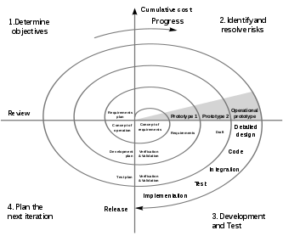Figure 7.12: Spiral Model

Definition
The Spiral Life Cycle Model is a type of iterative software development model which is generally implemented in high risk projects. It was first proposed by Boehm. In this system development method, we combine the features of both, waterfall model and prototype model. In Spiral model we can arrange all the activities in the form of a spiral. Each loop in a spiral represents a development phase (and we can have any number of loops according to the project). Each loop has four sections or quadrants :
- To determine the objectives, alternatives and constraints. We try to understand the product objectives, alternatives in design and constraints imposed because of cost, technology, schedule, etc.
- Risk analysis and evaluation of alternatives. Here we try to find which other approaches can be implemented in order to fulfill the identified constraints. Operational and technical issues are addressed here. Risk mitigation is in focus in this phase. And evaluation of all these factors determines future action.
- Execution of that phase of development. In this phase we develop the planned product. Testing is also done. In order to do development, waterfall or incremental approach can be implemented.
- Planning the next phase. Here we review the progress and judge it considering all parameters. Issues which need to be resolved are identified in this phase and necessary steps are taken. Subsequent loops of spiral model involve similar phases. Analysis and engineering efforts are applied in this model. Large, expensive or complicated projects use this type of life cycle. If at any point of time one feels the risk involved in the project is a lot more than anticipated, one can abort it. Reviews at different phases can be done by an in-house person or by an external client.

7.13 Type of Testing in Cloud
- Testing of the whole cloud: The cloud is viewed as a whole entity and based on its features testing is carried out. Cloud and SaaS vendors as well as end users are interested in carrying out this type of testing
- Testing within a cloud: By checking each of its internal features, testing is carried out. Only cloud vendors can perform this type of testing.
- Testing across cloud: Testing is carried out on different types of cloud like private, public and hybrid clouds.
- SaaS testing in cloud: Functional and non-functional testing is carried out on the basis of application requirements.

Other Testing types in Cloud includes
- Performance
- Availability
- Compliance
- Security
- Scalability
- Multi-tenancy
- Live upgrade testing
Cloud testing focuses on the core components like:
- Application: It covers testing of functions, end-to-end business workflows, data security, browser compatibility, etc.
- Network: It includes testing various network bandwidths, protocols and successful transfer of data through networks.
- Infrastructure: It covers disaster recovery test, backups, secure connection and storage policies. The infrastructure needs to be validated for regulatory compliances.

7.14 Test Cases for Cloud Testing
Test Scenarios | Test case
Performance Testing | Failure due to one user action on cloud should not affect other users performance.
Performance Testing | Manual or automatic scaling should not cause any disruption
Performance Testing | On all types of devices the performance of the application should remain same
Performance Testing | Overbooking at supplier end should not hamper the application performance
Security Testing | Only authorized customer should get access to data
Security Testing | Data must be encrypted well
Security Testing | Data must be deleted completely if it is not in use by client
Security Testing | Data should be accessible with insufficient encryption
Security Testing | Administration on suppliers end should not access the customers data
Security Testing | Check for various security settings like firewall, VPN, Anti-virus etc
Functional testing | Valid input should give the expected results
Functional testing | Service should integrate properly with other applications
Functional testing | System should display customer account type when successfully login to the cloud
Functional testing | When customer chose to switch to other service the running service should close automatically

Interoperability & Compatibility Testing | Validate the compatibility requirements of the application under test system
Interoperability & Compatibility Testing | Check browser compatibility on cloud environment
Interoperability & Compatibility Testing | Identify the Defect that might arise while connecting to cloud
Interoperability & Compatibility Testing | Any incomplete data on cloud should not be transferred
Interoperability & Compatibility Testing | Verify that application works across different platform of cloud
Interoperability & Compatibility Testing | Test application on in-house environment and then deploy it on cloud environment
Network Testing | Test protocol responsible for cloud connectivity
Network Testing | Check for data integrity while transferring data
Network Testing | Check for proper network connectivity
Network Testing | Check if packets are being dropped by firewall on either side
Load and Stress Testing | Check for services when multiple users access the cloud services
Load and Stress Testing | Identify the Defect responsible for hardware or environment failure
Load and Stress Testing | Check whether system fails under increasing specific load
Load and Stress Testing | Check how system changes over time under a certain load

CHAPTER 8
8. SNAPSHOTS
8.1 Coding View On-Demand:

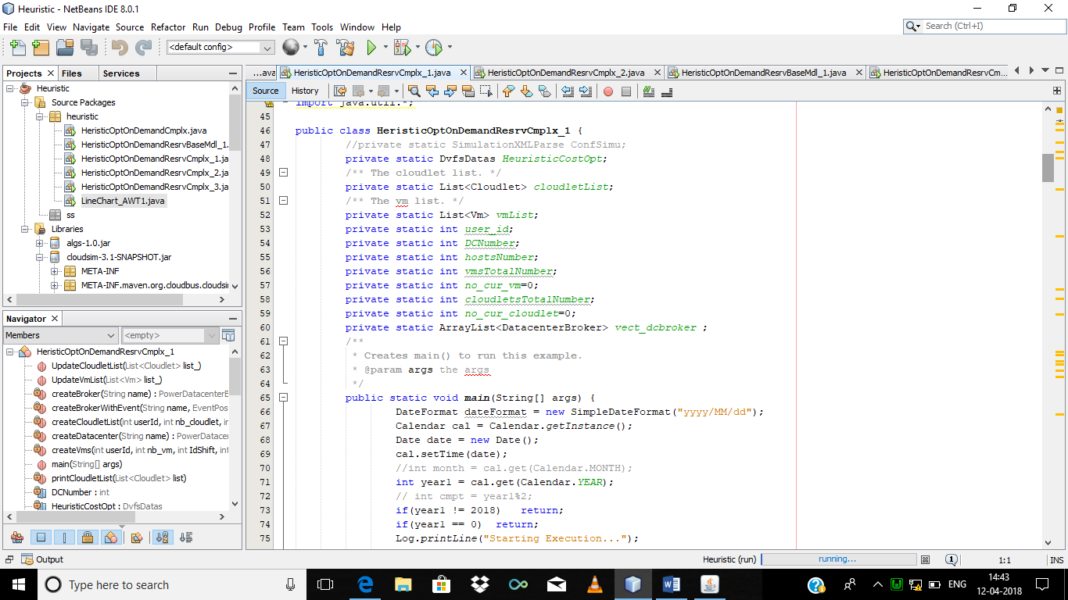
Figure: 8.1

8.2 Coding View Reservation:

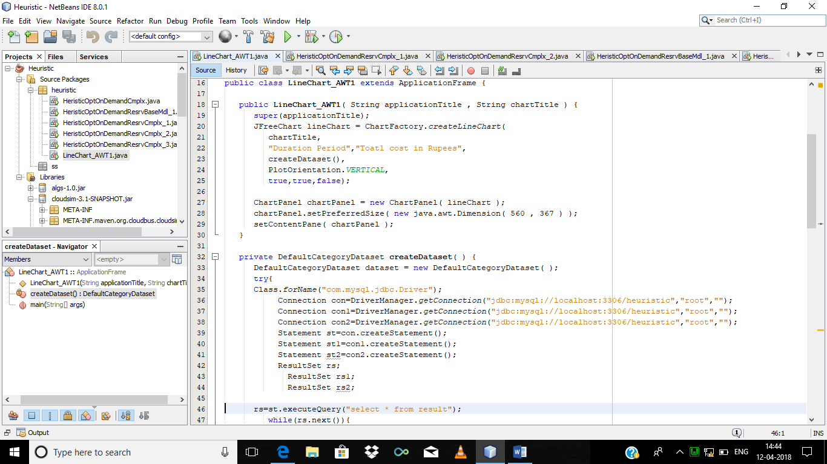
Figure: 8.2

8.3 Heuristic run:

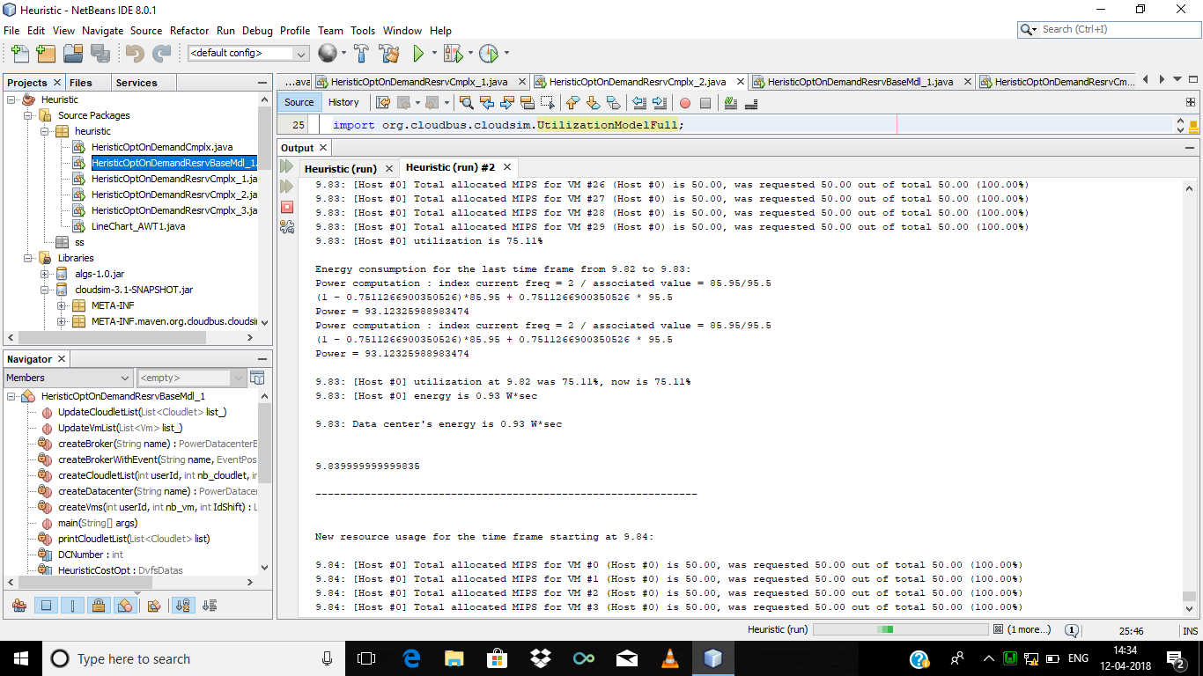
Figure:8.3

8.4 Resource Utilization Cost On a Graph:

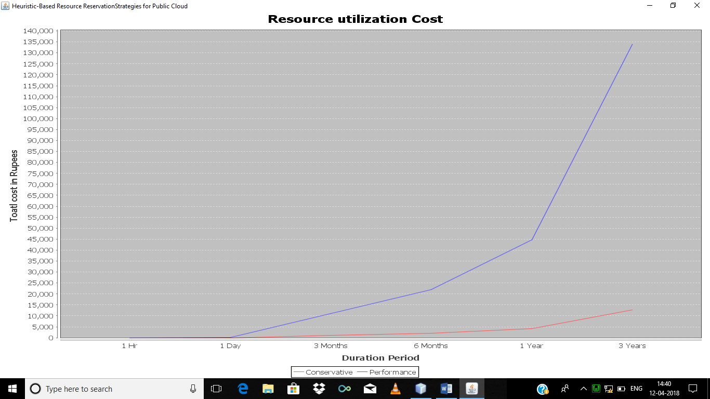
Figure:8.4

8.5 Result 1 In WampServer:

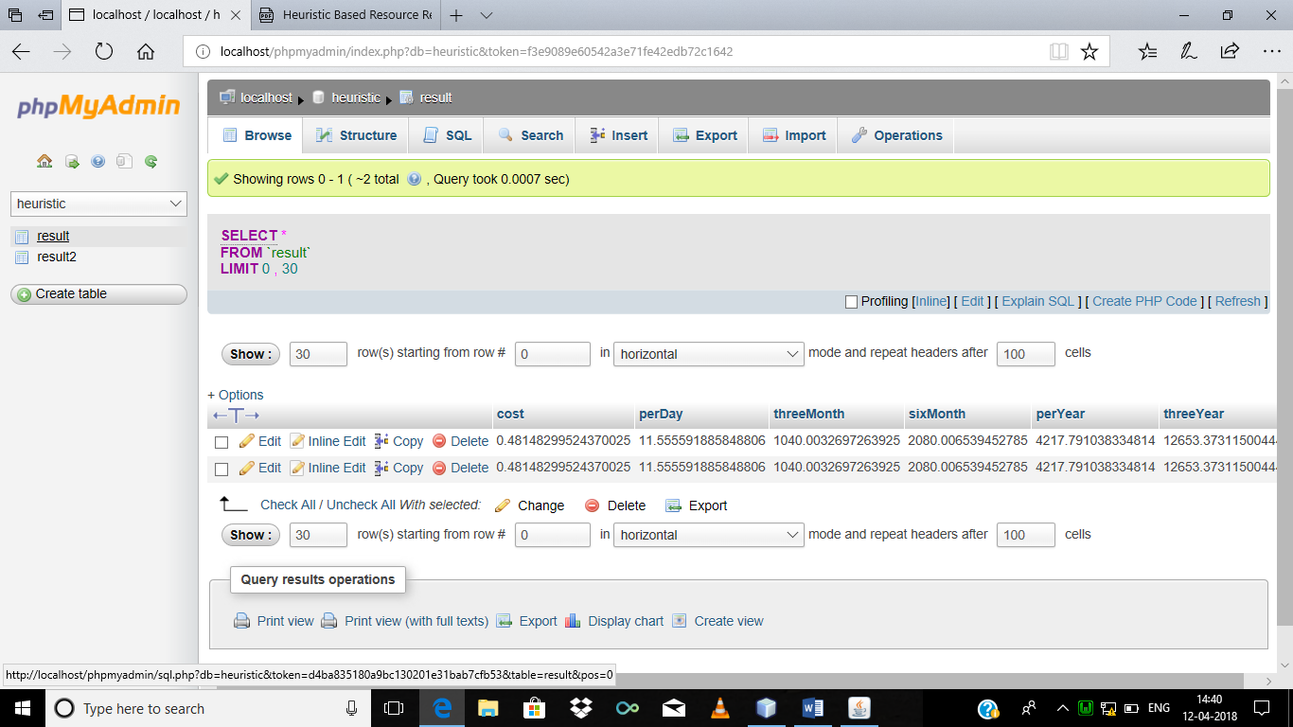
Figure:8.5

8.6 Result 2 In WampServer:

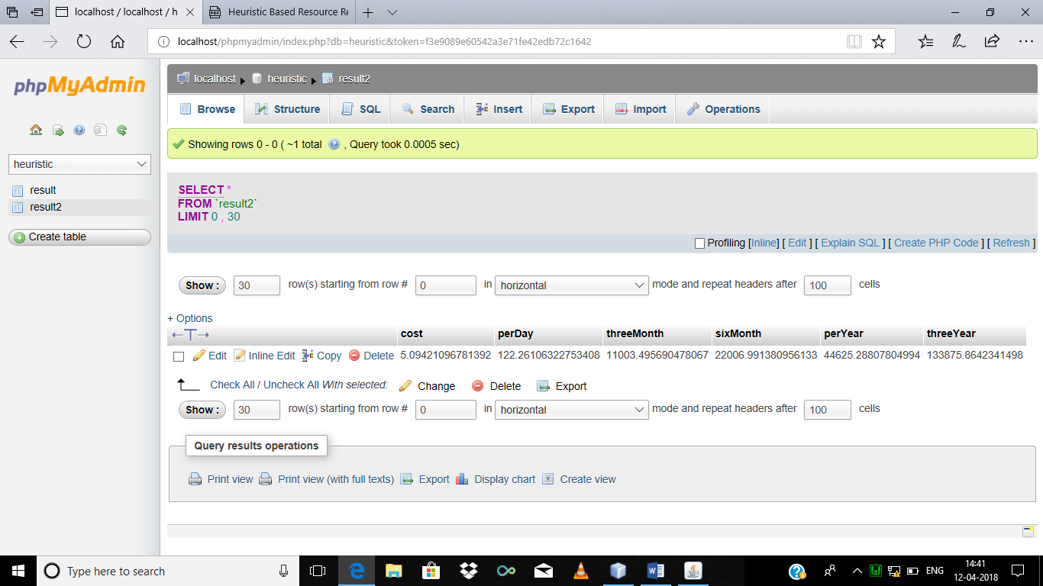
Figure:8.6

CHAPTER 9
9. RESULT ANALYSIS

TABLE 1
Cost Reduction (in Percent) of Different Reservation Strategies
Duration (months) | 3 | 6 | 9 | 18 | 24 | 30
Single Contract  (one-year) | 0 | 6.87 | 18.76 | 15.53 | 19.78 | 16.53
Single Contract  (Three years) | 0 | 4.08 | 19.41 | 28.23 | 33.06 | 33.31
Multiple Contracts | 0 | 6.87 | 19.63 | 28.23 | 33.06 | 33.31

same time, the linear time heuristic makes it possible to work on hourly demand data of length 3 years or more without any difﬁculty. We can conclude that the proposed heuristic based approach help to overcome the drawback of IPP based method sacriﬁcing very little on the total cost incurred. To simplify the heuristic, we have ignored the uncertainty of demands and prices in this work. Future work in this area could be how to bring those uncertainties into consideration. We would also like to include the option of spot pricing scheme to minimize the total cost further.

TABLE 2
Cost Reduction (in Percent) of Different On-Demand Strategies
Duration (months) | 3 | 6 | 9 | 18 | 24 | 30
Single Contract  (one-year) | 0 | 8.41 | 18.79 | 16.58 | 18.47 | 17.50
Single Contract  (Three years) | 0 | 5.51 | 19.25 | 24.17 | 28.00 | 30.64
Multiple Contracts | 0 | 8.41 | 19.49 | 24.20 | 28.20 | 30.66

CHAPTER 10
10. CONCLUSION
In this, we have proposed a heuristic-based algorithm to solve the cost optimization problem of cloud resource provisioning in linear time. We have mathematically proved that the heuristic provides optimal solution under some restrictions. We then extend the heuristic to cover the situations where these restrictions are removed. The experimental results show that the solution is very close to the optimal one with minimal overhead. Even though the IPP based approach gives the best solution for the problem, the total number of variables becomes too large if demand data is of duration more than six months and thus become impossible to solve by existing softwares like GLPK. At the

CHAPTER 11
11. REFERENCES
- IEEE transactions on cloud computing: Heuristic-Based Resource Reservation Strategies for Public Cloud
- https://aws.amazon.com/ec2/pricing/on-demand/
- Amazon EC2 REserved Instances [Online]. Available: https://aws.amazon.com/ec2/pricing/reserved-instances/
- Standard Workload Archieve [Online]. Available from:
http:// www.cs.huji.ac.il/labs/parallel/workload/logs.html

http://home.cse.ust.hk/~weiwa/teaching/Fall15-COMP668B/reading_list/AboveTheClouds.pdf

https://www.itu.int/dms_pub/itu-t/oth/15/08/T15080000050001PDFE.pdf

http://collaborate.nist.gov/twiki-cloud-computing/pub/CloudComputing/ReferenceArchitectureTaxonomy/NIST_SP_500-292_-_09068.pdf

- http://www.sciencedirect.com/science/article/pii/S187770589023259

- Cloud Simulation Package
- JAVA – The Complete Reference
- Amazon EC2 Pricing Schemes [Online]. Available:

